Phonics Policy

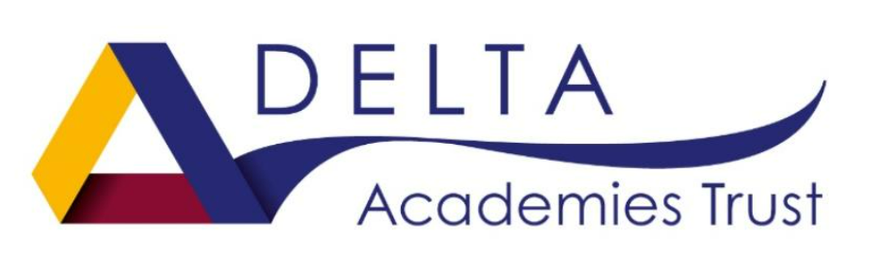

Estcourt Primary Academy

Contents:

- Statement of Intent

- Non-Negotiables
  - Language
  - Overview of phases
  - Presentation
  - Structure of lessons
  - Assessments – phonics tracker

- Outcome Statements – A journey

- Long Term Plan – Foundation Stage 1

- Long Term Plan – Foundation Stage 2

- Long Term Plan – Year 1

- Long Term Plan – Year 2

- Long Term Plan – Key Stage 2
  - Children who scored 32-36 in phonics screening check
  - SEN & those that did not pass
  - New to English (EAL)

- Interventions
  - KS1 & SEN
  - KS2

1
Statement of Intent

At Estcourt Primary Academy we strive for all children to become confident, fluent, and passionate readers, quickly. We aim to develop pupils’ reading through progressive phonics teaching, guided reading, home reading and reading strategy teaching, so that children will learn to read widely, fluently, accurately, frequently and with good understanding and pleasure.
Our curriculum is formed by our school vision, which enables all children, regardless of their starting point to exceed and grow into lifelong learners who will make a positive contribution to society.
Intent:
- For children to be accurate and fluent readers,
- For children to be confident in their reading of a wide variety of genres,
- For children to not only read well, but understand what they are reading,
- To inspire children with books and encouragement to embed a love of reading and story-telling,

For children to be able to achieve these intentions, we provide them with a consistent and engaging approach of phonic teaching, following Essential Letters and Sounds. We believe every child should leave Estcourt Primary with the skills of an outstanding reader and writer.

From the moment they enter nursery, children are exposed to a variety of sounds throughout the day (environmental and instrumental) with the emphasis on talking and listening. Phase One in Nursery plays a vital role in a child’s introduction to phonics. Alongside Phase One, children are tracked throughout the stages of the current Launchpad to Literacy document which supports developmental increments in all areas relating with speech, language, vocabulary, and phonological awareness.
Daily phonics lessons are taught from Foundation Stage 2 (F2), where children will be introduced to phonemes and graphemes. F2 incorporates Phase 2-4 throughout the year, and they are introduced to phase 5 in the summer term. They will develop their ability to segment and blend phonemes together to say a word. Opportunities for reading are provided through daily fluency reading sessions and endless opportunities for children to practice and apply their learning in provision. Children are provided with fully decodable books that are matched to their ability.
In year 1, these skills are built upon further, where children can revisit prior phases of phonics and learning. Daily phonics sessions continue into year 1 most specifically incorporating phase 5 throughout most of the year. They continue to build upon that by learning alternative spelling and pronunciation. Daily phonics and where appropriate daily interventions are given to children to help them in their reading and writing skills. Phonics plays a hugely important part in year 1 as the statutory Screening Test is taken during this year. Staff work closely with children and parents to provide as many opportunities as possible to revisit and apply their knowledge. We hope that this provides children with the tools to achieve success in their Screening.
Alongside the teaching of phonics in Year 1, the children also have daily fluency group and 1:1 intervention sessions. This session provides opportunities for the children to practice their newly taught phonic skills in context, along with promoting and embedding fluency. Fully decodable books are an integral part of this strategy and are used throughout Foundation Stage and Key Stage 1. Children are provided with books to take home that they can decode and feel confident reading, as well as a book for pleasure. We want children to leave Year 1 with the confidence to read in a fluent and accurate manner and support our families to achieve this aim.

Year 2 consolidates all previous learning and expands upon it once again. Children can practice and revisit their knowledge and apply that to their reading and writing. The emphasis moves towards spellings, homophones, and suffixes. Children are still provided with decodable books which help revisit and maintain good phonetic knowledge. At this stage, most children should have passed their phonics screening and have good level of phonetic knowledge to start building up their fluency. Building up fluency is a key focus alongside developing confidence and understanding readers. Every year however there are children who retake the Screening Test in year 2. These children continue with the teaching and learning of phonics with the main class body and supplement this with further interventions to close gaps, specific to their need. These interventions are individual specific and match to specific gaps in learning.

KS2 onwards
As children move further up school, support with phonics continues. At Estcourt Primary we strive to ensure that children are given the opportunity to continue to practice their skill and phonics knowledge and where appropriate children are still provided with books to match their fluency and understanding. We are extremely fortunate that we are gifted with children from different ethnicities and backgrounds, therefore we respect that English is not always their first spoken language and understand that the process to learning English may take longer than others. With this in mind, we feel it is beneficial to have strategies in place to support those in need.

All key stage 2 phonic interventions are structured in the same way following Essential Letters and Sounds. We have incorporated the non-negotiables from Essential Letters and Sounds within school to ensure that all staff are consistent in their approach when teaching phonics and all members of staff are fully trained.

2
Non-negotiables

Non-negotiables

A consistent approach to phonics is the focus at Estcourt Primary Academy. We believe consistency delivers excellent results. It is important that phonics is familiar, and the children are comfortable and confident during all phonics lessons. The focus of the children should be on new sounds and words, rather than new methods of learning. With this in mind, we have created non-negotiables for all staff to follow to ensure a high-quality consistent approach across the whole academy.

a.) Language:
At Estcourt Primary we hold a high standard and are particular about using the correct terminology when teaching phonics to the children. This terminology needs to be used from nursery up through to Year 6.

Name | Meaning
Phoneme | The smallest unit of sound in a word
Grapheme | A letter or group of letters representing one sound (phoneme)
Digraph | Two letters which together make one sound. There are different types of digraphs – vowels, consonant and split.
Trigraph | Three letters which together make one sound.  e.g: igh in night, air in hair
Split digraph | Two letters, which work as a pair to make one sound, but are separated within the word.  e.g: a-e in cake
Segmenting | Splitting a word up into individual sounds – used when spelling and writing. When learning new words, children are encouraged to segment the word and then blend it together.  e.g: ship would be sh-i-p
Blending | Saying the individual sounds that make up a word and then merging or blending the sounds together to say the word – used when reading.  e.g: s-n-a-p would be snap
Pure Sounds | Pronouncing each letter sound clearly and distinctly without adding additional sounds to the end.  e.g: /f/ not /fuh/  TOP TIP! – Some sounds are hard to add emphasis too. There it is easier to say by dragging out the sounds.  e.g: ffffff is better than /fuh/ or mmmm is better than /muh/
Adjacent Consonants | Two or three letters making two and three sounds.  e.g: the first three letters of strap are adjacent consonants
Syllables | A unit of pronunciation having one vowel sound, with or without surrounding consonants – forming the whole or part of a word.  e.g: water has two syllables
Polysyllabic | Words which have two or more syllables.  e.g: shampoo or chimpanzee
Alternative Pronunciation | Alternative way to say the same letter.  e.g: /c/ can be cat but /c/ can be ice, pronounced /s/
Alternative Spelling | Alternative way to say the same sound but with different spelling.  e.g: oa in goat can make ow in snow.
Pseudo Words | A string of letters that may resemble a conventional word but does not appear in a dictionary. Pseudo words are in the phonics screening, and they provide an additional evidence base of a child’s phonic ability in segmenting and blending words that make no sense.
Harder to read and spell words (HRS) | Words that are not phonetically decodable with an unusual or uncommon spelling.  e.g: people, because
High Frequency Words | Common words that appear often in written text. A mixture of decodable and HRS words.
Decodable Words | Words that can be segmented and blended together
Homophones | Two or more words that have the same pronunciation, but different meaning, origins or spelling.  e.g: knew, new
Contractions | A word or group of words resulting from shortening an original form.  e.g: do not – don’t
Suffixes | Added to the end of a word to form a derivative.  e.g: ing, s, es, ed
Prefix | Added to the beginning of a word to form a derivative.  e.g: pre, un, dis
Consonants | Basic speech sounds in which the breath is at least partly obstructed and which can be combined with a vowel to make a syllable.  b c d f g h j k l m n p q r s t v w x y z
Vowel | A speech sounds which is produced by the vocal tracts and vibrations of the vocal chords and can form a syllable.  a e i o u

b) Overview of Phases
Phase | Meaning
1 | This is split into 7 aspects. This is a vital part of phonics. It focuses on hearing and talking about environmental sounds, instrumental sounds, voice sounds, oral blending, and segmenting.  There are links with the phonological awareness strands of Launchpad for phase 1 also.
2 | * Oral blending  * Sounding out and blending with 23 new graphemes  * Phoneme correspondences (GPCs)  * 12 new harder to read and spell (HRS) words
3 | * Oral blending  * Sounding out and blending with 29 new GPCs  * 32 new HRS words  * Revision of Phase 2  Phase 3 of ELS covers more than just the Phase 3 graphemes – there is challenge from Phase 4 (in the form of adjacent consonants) alongside the Phase 3 teaching to extend children’s sounding out and blending skills.
4 | * Oral blending  * No new GPCs  * No new HRS words  * Word structures – CVCC, CCVC, CCVCC, CCCVC, CCCVCC  * Suffixes  * Revision of Phase 2 and Phase 3
5 | * Introduction to Phase 5 for reading  * 20 new GPCs  * 16 new HRS words  Year 1 Autumn 1 and 2  * Revision of previously taught Phase 5 GPCs  * 2 new GPCs  * 9 new HRS words  Year 1 Spring 1 and 2  * Alternative spellings for previously taught sounds  * 49 new GPCs  * 4 new HRS words  * Oral blending  * Revision of Phase 2, Phase 3 and Phase 4
6 | With ELS, phonics teaching does not stop at the end of Year 1, but continues as children move through the school, with links being made between their GPC knowledge and spelling  * Revision of all previously taught GPCs for reading and spelling  * Wider reading, spelling and writing curriculum

c.) Presentation
Text colour:
Black

Sound Buttons:
Colour: Red
One letter phoneme

Two or more letter phoneme

Split digraph

Examples of sound buttons:
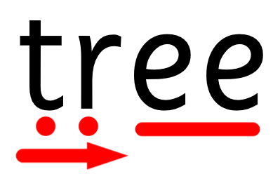
In F2 phase 4 blends are introduced in the summer term. Blends are made up of phonemes which are blended to one sound. There one letter phonemes need to be kept (to show children’s understanding) but then an arrow needs to be placed underneath to indicate that these phonemes can be blended. Language around tricking your mouth is used to show children that both single phonemes and blends can be used and supports the children in their sequential auditory memory.
e.g. initially children would learn t-r-ee, now they would be exposed to tr-ee.

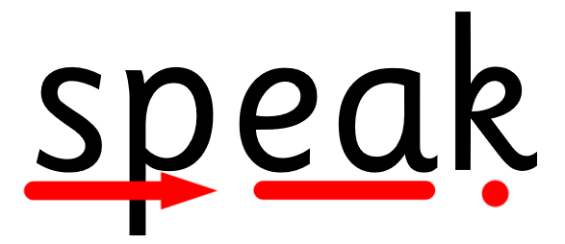
As children become more confident with phase 4 blends the phoneme dots will be completely replaced with the arrow. This should usually happen Autumn 2 of Year 1. Children need to recognise blends to help segment longer words
e.g. children will now move on from s-p-ea-k to sp-ea-k. This helps with sequential auditory memory as there are less phonemes to remember to blend together.

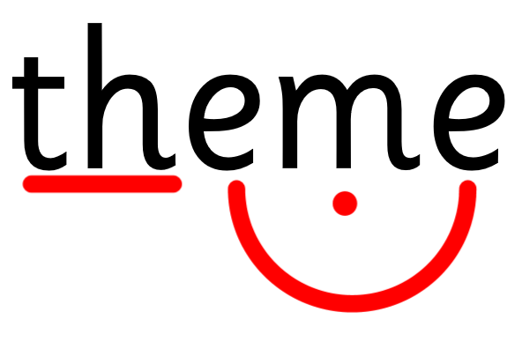
An example of a split digraph.

Robot hands and blending hands:
When segmenting and blending words together, robot arms are used to model. These help children blend and segment the word. Robot arms are used for each phoneme and hands are joined together at the end to hear the whole word.
Background:
For any slides, background needs to be plain.
Images:
Interactive Whiteboard Presentations have been created by ELS and clip art images are used to support the contextual nature of any new vocabulary. Real images can further support these presentations where necessary.
Displays:
Working walls and interchangeable on a weekly basis. The working wall should be a teaching tool and should be referred to throughout the day to children. Children should look to the working wall to guide them and provide additional support in their learning.
All working walls should have the following:

- Area to highlight sound(s) of the week
  - Words and pictures to support the children’s learning
- Harder to read and spell words
  - Key words of that week
- Apply
  - Where children can apply their knowledge
- Sentence level
  - A sentence that children can read and decode, spotting that sound(s) that have been taught.
d) Structure of lessons
ELS lessons are active – children are engaged at all times, whether joining in with a ‘drum roll’ to introduce the new sound, using ‘robot arms’ or ‘tracking the teacher’ as you move around the room.

The structure of every phonics lesson is consistent.
Revisit and review
/
Teach
/
Practice
/
Apply
/
Revisit and review (this can happen after the lesson or at different parts of the day, dependent on the age of the children.)

The Phonics session will always follow the same structure.

Review-Revisit:
- Phoneme Flashcards
  - Previously taught graphemes – up to 12. Either the most recent phonemes or those that have challenged the children in recent sessions.

- Harder to read and spell words
  - Previously taught hard to read words

- Oral Blending
  - Using the method of ‘me than you’ up to eight words that the children do not decode.

- Decoding
  - Read words with previously taught graphemes
Teach:
- Harder to read and spell words
  - New harder to read and spell word, adding it to a verbal sentence modelled initially by practitioner

- Phoneme
  - Drum roll and introduction of new phoneme – me then you.

- Grapheme
  - Introduction of the grapheme

- Mnemonic
  - Show and teach the mnemonic

- Context
  - Show pictures of objects that have the new phoneme within them. Focus on the sounds, i.e ai…ai….rain

- Formation
  - Demonstrate how to form the grapheme, consistently using the mnemonic language to remind children
  - Children then write the grapheme, using the body, on the carpet or in the air.

Practise:
- Reading
  - Read words with newly taught graphemes – me then you
  - Encourage children to say, spot, sound out, blend, say the full word and use in context
  - Use flashcards, including the newly taught grapheme
Apply:
- Reading
  - Read captions and/or sentences with newly taught GRC and harder to read and spell words
  - Apply worksheet available within the workbook
  - Decodable reader

Review and revisit:
- Review the whole lesson at the end of the session or at points in the day.

e) Assessment:
It is important to assess the children on a regular basis, as this provides an analysis of each individual child’s learning gaps. This analysis will highlight specific sounds that need to be revisited to help children in their learning. This becomes extremely useful information when organising interventions. Termly assessments allow us to plug gaps efficiently and see which children need extra support in their phonics.
Daily assessments are also made, and interventions put in place within the taught lesson. These interventions support children who showed signs of weakness within the lesson and the additional support enables them to keep up, and not continually catch up.
Estcourt Primary Academy currently use Phonics Tracker (except nursery) which is an online tool to assess and store data. This provides gap analysis by phoneme, child, age, gender, SEND etc. It also provides worksheets for children personalised to their needs and gaps so they can improve their phonics.
Nursery have a separate assessment tool linked to the Launchpad for Literacy toolkit. This is as phonics tracker does not provide assessment for nursery. This is broken down into Aspects and within those key skills that children should build up throughout nursery.

Phonics Tracker Website
www.phonicstracker.co.uk
Username and Password is set up by the phonics lead. Please see Tanya Freeman if you do not have a username set up on phonics tracker.

3
Outcome Statements

Estcourt Primary Academy has created outcome statements throughout the EYFS and KS1 to help guide and support teachers in their assessments of pupils.

Outcome Statements are based on the average child and where they should be to pass their phonics screening in Year 1. This guide is for teachers to support children efficiently and effectively.

Each year group has a Long-Term Plan, which includes the books in which the child should be reading (100% match to their ability) alongside when to assess a child and the progress they should be typically making.

This progress is tracked and evidenced on each child’s individual Phonics Journey – a simple tool for teachers to keep track if a child is making enough progress.

The outcome statements determine children who may need additional support and it is easily highlighted this way. Teachers are then able to prepare interventions, resources, and plan accordingly to each child’s needs.

Key Stage 2

In an ideal school most children should pass the phonics screening assessment by the end of KS1. There are instances and exceptions where children are unable to access the rate of learning needed and will require further support in their understanding of phonics. We strive to continue to support all children in their phonic development and therefore plan careful ELS/ fluency interventions to provide every child with the tools to make them confident and fluent readers.

This isn’t solely linked to Year 3 but is managed and tracked throughout KS2 and discussions are had with class teachers on a regular basis surrounding phonics and fluent reading.

4
Nursery – Long Term Plan

At Estcourt Primary we are fortunate that we are able to support children in their phonics journey from Phase 1. Following Essential Letters and Sounds, Phase 1 is focused on developing speaking and listening skills, the emphasis being for children to become attuned to the sounds around them. These skills also lay the foundation for segmenting and blending later in phase 2.
Phase 1 is divided into seven aspects, with the first six being nonconsequential. This allows practitioners to provide opportunities from any of the first six aspects in any order, at any time. It allows clear skills gaps to be filled with either individuals or groups of children.
Aspect 7 usually comes later when children have had opportunities to develop their skills.

Aspect 1 – General sound discrimination – environmental
Begin to raise awareness of the sounds around them and to develop their listening skills. Activities could include a listening walk, drumming items in various locations (inside and outside) making shakers
Aspect 2 – General sound discrimination – instrumental sounds
Develops children’s awareness of sounds made by instruments and noise makers. Activities include comparing and matching sounds, playing a variety of instruments – making quiet and loud sounds.
Aspect 3 – General sound discrimination – body percussion
Develops children’s awareness of rhythm and sounds. Activities include singing, rhymes and listening to music.
Aspect 4 – Rhythm and rhyme
Develop children’s experiences of rhythm and rhyme in speech. Activities include rhyming stories, clapping out syllables in words.
Aspect 5 – Alliteration
Focus is on initial sounds of words, with activities including I-spy,
Aspect 6 – Voice sounds
Children begin to start to distinguish between different vocal sounds and begin oral blending and segmenting.
Aspect 7 – Oral blending and segmenting
The main aim is to develop oral blending and segmenting skills. Children start to practice oral blending, using their listening skills to help them distinguish segmented letters into one blended sounds.

5
Foundation Stage 2 – Long Term Plan

At the start of F2 children begin with a recap on Phase 1. This is to gain a good understanding of children’s prior understanding and to recap learning from previous years. After this re-cap, Phase 2 sounds are introduced, which include 19 letters of the alphabet. These are split into sets and are introduced one at a time and in a set order.
Set 1: s a t p
Set 2: m i n d
Set 3: g o c k
Set 4: ck e u r
Set 5: h b f ff l ll ss
Children are encouraged to use their prior knowledge from nursery to listen to the letter sounds to blend and sound out the words. They will also begin to start learning how to segment words into letter sounds. Additional to these skills, children will be introduced to ‘harder to read and spell’ which are words that are not phonetically decodable and or have uncommon or unusual spelling. After learning each set, consolidation weeks will be filtered into learning to address any misconceptions and ensure knowledge is embedded.

Children then move onto Phase 3 where they learn the rest of the letters of the alphabet and then move onto digraphs. Children will also learn the letter names of the alphabet during this time. More tricky words are given to children to learn to read and spell thus also developing their vocabulary and language skills.

Set 6: j v w x
Set 7: y z zz qu
Consonant digraphs: ch sh th ng nk
Vowel digraphs: ai ee igh oa o oar or ur ow oi ear air er

For most children, Phase 4 is introduced. Phase 4 is slightly different to the other phases, as children are not learning any new sounds. This phase focuses on blending and segmenting longer words with adjacent consonants (br, fl, cr) and more than one syllable (polysyllabic). Alongside this, children are introduced to new harder to read and spell words.
Alongside the teaching of Phase 4, graphemes from other phases will be integrated into the learning opportunities to consolidate all the prior learning. There is a five-week introduction to phase 5 within the summer term.

6
Year 1 – Long Term Plan

At the beginning of year 1, phase 5 is recapped for the initial eight weeks. This allows children to be familiar with sounds they are already aware of, whilst practicing the blends of sounds. During this time, assessments will take place to get a clear understanding of each child’s capabilities.
Following this recap, children will continue to move through phase 5, where they begin to learn alternative graphemes and phonemes linked with sounds they may already have been taught. As an example, they already know /ee/ as in bee but now they will be introduced to /ea/ as in bead and /e_e/ as in even. These spellings will be taught alongside the phase 3 digraphs that the children are already familiar with.
Throughout Phase 5 children will be exposed to phase 3 spellings along with phase 4 consonant blends. This practice embeds the children’s knowledge and understanding of the phonemes along with constantly recapping prior learning and further embedding this.
At the beginning of June, children take part in the Phonics Screening Check. This tests their ability to segment and blend words together. Within the assessment, they are exposed to both real and pseudo words along with graphemes from phases 2 to 5. Blends make up a large section of the test, therefore it is important that blends are taught within any phase you may recap. Within Year 1, there is ample opportunity to recap sounds and it is important that gaps in a child’s knowledge are addressed and supported through quality teaching and where necessary carefully planned interventions.
Alternative pronunciations and spellings for graphemes are introduced later in the school year. For example, /ea/ as in tea, can be head and break however sound differently in each word. Word and spelling knowledge will be worked on extensively in preparation for phase 6 in Year 2.
By the end of Year 1, children should have passed their phonics screening test and should be confident in segmenting and blending sounds to read words.

7
Year 2 – Long Term Plan

At the beginning of Year 2 a recap of phase 5 will take place. This may not be all sounds; it may be gaps noted in assessments or fluency read observations.
Children have already learnt the most frequently occurring grapheme-phoneme correspondences and should be able to apply these to read many words automatically. When they do see an unfamiliar word, they should be able to decode these quickly using the skills they have learnt throughout F2 and Year 1.

At this stage children will move onto phase 6, where the emphasis is focused more towards spelling. Phase 6 focuses on accurate spelling and spelling rules, whilst also developing children into more fluent and expressive readers.

8
KS2 – Long Term Plan

Who may need additional support?

- Children who did not pass the phonics screening check by the end of KS1
- Children who scored between 32-36 on the phonics screening in Year 2
- SEN children
- EAL (English as an Additional Language) / NTE (New to English) children
(Please note the children in the below category may not need this support, it depends on the individual child and their needs)

Children who scored 32-36 in the screening check in Y2:
Although these children did pass their phonics screening, it is imperative they still receive additional support. As they just secured the pass mark, this does not mean their phonic knowledge is as secure as it could be. It is important, especially at the beginning of their entry into KS2 they are provided with additional support.
Please follow the guidance below for these children. Interventions may not take place throughout the whole year for each child. However, it is important in the first term at least, regular interventions are in place to support.

Date | Assessment | Outcome | Progress
Autumn 1  Week 1 | Do a phase assessment, using phonics tracker.  * Phase will be determined by prior learning.  * May need to assess more than one phase.  * If the child is struggling with the phase selected – go back to the previous phase. | From this, gaps will be determined in their knowledge.  From this, interventions are put into place to target the sounds that they are not familiar with.

Autumn 1  Last Week | Do a phase assessment on Phonics Tracker  (Phase dependent on child) | To assess if the interventions are having a positive impact. | From this, you should have seen progress in the sounds they have had interventions with.
Autumn 2  Last Week | Phonics Screening check on Phonics Tracker | Assess where the child is across their whole phonics knowledge.  This will give you sounds to focus on for next interventions if needed. | Should have seen an increase in their previous screening test.  If a child scores above 36, then interventions may not be necessary (teacher judgement)  If a child is still scoring between 32-36 interventions needs to continue.
Spring 1  Last Week | Phase Assessment using Phonics Tracker | From this you should be able to determine any gaps in their knowledge.  From this, interventions need to be put into place to target the sounds that they are not familiar with. | Should see some progress with the focus sounds.
Spring 2  Last Week | Phonics Screening check on Phonics Tracker | Assess where the child is across their whole phonics knowledge.  This will give you sounds to focus on for next interventions if needed. | Should have seen an increase in their previous screening test.  If a child scores above 36, then interventions may not be necessary (teacher judgement)  If a child is still scoring between 32-36 interventions needs to continue.
Summer 1  Last Week | Phase Assessment using Phonics Tracker | Assess where the child is across their whole phonics knowledge.  This will give you sounds to focus on for next interventions if needed. | Should have seen an increase in their previous screening test.  If a child scores above 36, then interventions may not be necessary (teacher judgement)  If a child is still scoring between 32-36 interventions needs to continue.
Summer 2  Last Week | Phonics Screening check on Phonics Tracker | Assess where the child is across their whole phonics knowledge.  This will give you sounds to focus on for next interventions if needed.  This will inform the next teacher on any sounds a child may still need support with. | Should have seen an increase in their previous screening test.  If a child scores above 36, then interventions may not be necessary (teacher judgement)  If a child is still scoring between 32-36 interventions needs to continue.

Non-negotiables
Children who did not pass the phonics screening or SEN children (who did not pass the test) are required to the following:
- A daily 5 min intervention on a 1.1 basis for at least autumn term.
- Read to an adult every day in a 1:1 session, with a 100% phonetically decodable book.
- Please use the long-term plan to follow order of sounds to teach and books the children can access.

Please see outline of a plan to follow in intervention section, for a more detailed approach on how to execute the interventions.
SEN & those that did not pass the screening:
Not all SEN children will fall into this category, however those who this does apply to, need to be given regular daily interventions to support them in their reading. A personal plan should be in place for each individual child.

Date | Assessment | Outcome | Progress
Autumn 1  Week 1 | Do a phase assessment, using phonics tracker.  * Phase will be determined by prior learning.  * May need to assess more than one phase.  *If the child is struggling with the phase selected – go back to the previous phase. | From this assessment use the analysis of phonics tracker to spot any gaps in their learning.  Focus on a sound per week –  When discovering gaps a child should be accessing unfamiliar sounds 20 minutes a day either in 1:1 intervention or group intervention. | Progress is dependent on the child and their individual needs. Therefore, no real benchmark can be set.
Autumn 1  Last Week | Do a phase assessment using phonics tacker. The assessment should be on a phase that include the sounds that they have been learning in the past 6 weeks.
Autumn 2  Last Week | Phonics Screening Check  (This is dependent on the child – some children may not be able to access the test)  Phase Assessment | From this it gives a good indicator on where the child is in term of whole knowledge of sounds.
Spring 1  Week 1 | Phase Assessment | As there has been a break in school, it is important to assess again, to get a sense of any loss of learning and understanding. | Progress is dependent on the child and their individual needs. Therefore, no real benchmark can be set.
Spring 1  Last Week | Do a phase assessment using phonics tacker. The assessment should be on a phase that include the sounds that they have been learning in the past 6 weeks. | From this assessment use the analysis of phonics tracker to spot any gaps in their learning.  Focus on a sound per week – following the strategy in  When discovering gaps, a child should be accessing unfamiliar sounds 20 minutes a day either in 1:1 intervention or group intervention.
Spring 2  Last Week | Phonics Screening Check  (This is dependent on the child – some children may not be able to access the test)  Phase Assessment
Summer 1  Week 1 | Do a phase assessment using phonics tacker. The assessment should be on a phase that include the sounds that they have been learning in the past 6 weeks.
Summer 1  Last Week | Phonics Screening Check  (This is dependent on the child – some children may not be able to access the test)  Phase Assessment | This assessment will support staff and the child going into next year.

Non-negotiables
Children who did not pass the phonics screening or SEN children (who did not pass the test) are required to the following:
- A daily 5 min intervention on a 1:1 basis
- Read to an adult every day in a 1:1 session, with a 100% phonetically decodable book.
- Please use the long-term plan to follow order of sounds to teach and books the children can access.
Please see outline of a plan to follow in intervention section, for a more detailed approach on how to execute the interventions.

NTE & EAL children:
At Estcourt Primary we are fortunate to have a diverse population of children, who speak a variety of different languages. Those who are learning English (as an additional language) need to be provided with the necessary support and skills to access the phonic curriculum as their peers had in previous years. We always strive to ensure that every child becomes a fluent and confident reader, regardless of their starting points.
The Long-Term Plan below, provides a starting point of assessments that need to take place in order to support NTE/EAL children in school. It is important that the plan is followed and assessed correctly, to provide the correct support for the child. This order follows Letters and Sounds (along with the rest of the school) and is aligned to the books that are in school. Following these sounds allows us to match books that are 100% decodable for each child to take home and read.
It is important that you follow the order of this plan.
Non-negotiables
- Need a 30 min phonics session every day. (could look at providing more opportunities for their phonics learning)
- During Literacy, it is important they continue to practice their phonic ability
- Reading with a member of teaching or support staff every day, following the read-repeat technique.

Week | Sound | Books | Assessment | Outcomes
1 | N/A | Lilac wordless books  Picture books  If possible a book in their own language | If & where possible assess the child in their own language. Simple picture matching. To gauge an idea of their understanding of their own language.  (see resources) | Be able to gain an understanding of a child’s ability in their own language.
 |  |  | Assessment of the alphabet  do they know some of the letters | See if they have any understanding of the English letters
 |  |  | Assessment of phase 2 sounds (if they know, move onto the following phases) | An assessment to see if they know any words or sounds.
The starting point for each child may vary depending on the sounds they already know. Go the appropriate sound and follow the guide.
2 | S A T P
3 | M I D N
4 | G O C K
5 | CK E U R
6 | H B F FF
7 | L LL SS
8 | Recap phase 2 sounds |  | Phase 2 Assessment on Phonics tracker | Should be achieving 95% above for phase 2 sounds.
9 | J V W X
10 | Y Z ZZ QU
11 | CH SH TH NG NK
12 | AI EE IGH OA
13 | OO OO AR OR UR
14 | OW OI EAR AIR
15 | URE ER
16 | Phase 3 recap |  | Phase 3 Assessment on Phonics tracker | Should be achieving 95% above for phase 3 sounds.
17 | Phase 4
18 | Phase 4
19 | Phase 4 |  | Phonics Screening Assessment | Should be achieving late teens to early 20s.
20 | Phase 4
21 | Phase 4
22 | Phase 4 |  | Phase 4 Assessment on Phonics tracker | Should be achieving 95% above for phase 4 sounds.
23 | AY OU IE EA
24 | OY IR UE AW
25 | WH PH EW OE |  | Phonics Screening Assessment | Should be achieving mid to late 20’s
26 | AU EY A-E E-E
27 | I-E O-E U-E C
28 | U AL  Review |  | Phase 5 Assessment on Phonics tracker | Should be achieving 95% above for phase 5 sounds.
29 | Recap |  | Phonics Screening Assessment | Should be achieving 32 or above

Once this plan is completed, please see Year 1 Long Term Plan for alternative pronunciation and spelling – Start at Spring 2 alternative pronunciations.

9
Interventions.

KS1 & SEN
In KS1 it is important to provide interventions to children who are not currently achieving at the standard that is required to help them pass the phonics screening.
Using the additional approach of Launchpad to Literacy as a guide, it is important to acknowledge that children require a set of skills before phonics can become accessible. With this in mind it is important that more focused and targeted interventions are provided to allow children to acquire the necessary skills in order to easily access new sounds and words. Launchpad to Literacy highlights key steps that provide teachers with support as to what a child can do rather than what a child can’t do. The approach highlight skill gaps in a child’s development and next steps are incremental and progressive. Generally, the most common strand of difficulty is linked with visual discrimination and auditory memory therefore providing interventions linked with these skills will help children in their development and understanding of phonics.
The three areas for Interventions are ‘Oral Blending’, ‘GPC Recognition’ and ‘Blending for Reading.’
Please see below guideline and plan for these interventions.
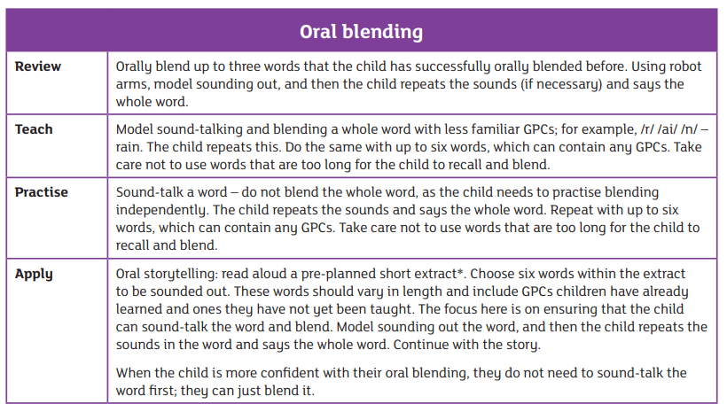
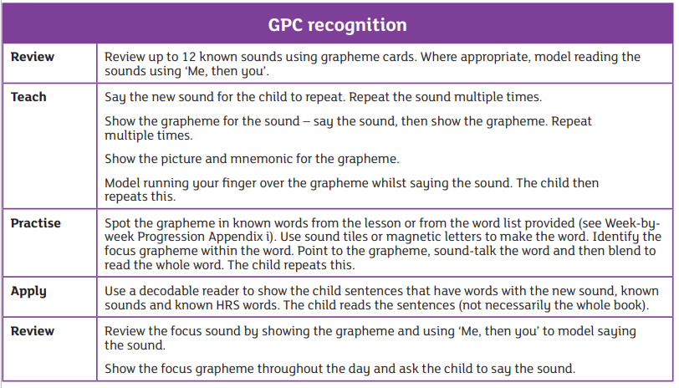
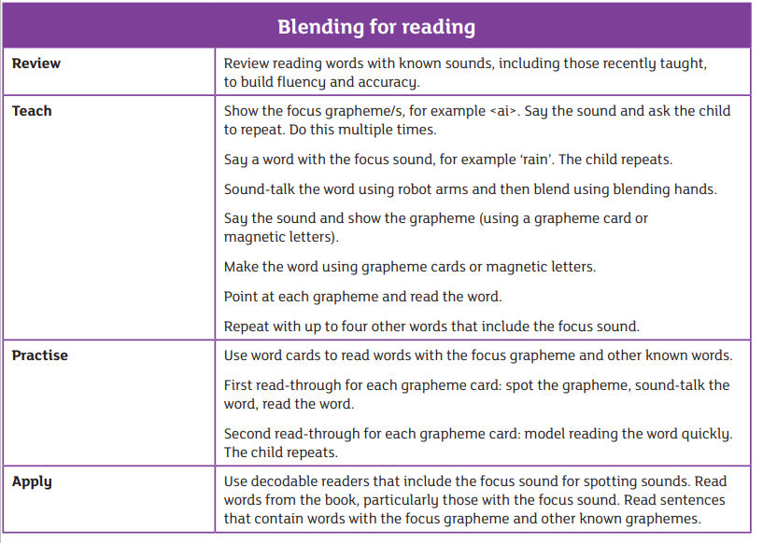

Interventions are multi-sensory and active providing opportunities for development alongside further consolidation. There will also be an emphasis on learn, repeat, learn and opportunities will be created throughout the day to repeat and embed learning from the intervention sessions.

Key Stage 2
Interventions play an important role in supporting children who may require extra support in their phonics knowledge. These interventions need to provide efficient and concise teaching, with a key focus on a sound or a family of sounds (dependent on the skill/grapheme gap)
Intervention groups should be 1:1 and follow a similar approach to that of Key Stage 1.

